SOMAIYA 

V I D Y A V I H A R

K J Somaiya Institute of Engineering and Information Technology

An Autonomous Institute Permanently Affiliated to the University of Mumbai

Accredited by NAAC with ‘A’ Grade (3.21 CGPA), Approved by AICTE, New Delhi

DEPARTMENT OF INFORMATION TECHNOLOGY



***Synopsis of Major Project On***

Web2Print

Prepared By:

Jeet Bhanushali (Roll No. 01)

Tejas Chaplot (Roll No. 03)

Adnan Kadiwala (Roll No. 42)

Under the guidance of:

Prof. Seema Yadav

**Department of Information Technology**

**Academic Year: 2022-2023**

**Autonomy Syllabus Scheme-I (2022-23) - SEMESTER VII (LY - IT)**



**CERTIFICATE**

## This is to certify that following students:

Roll No. / Seat No.

Jeet Bhanushali 01

Tejas Chaplot 03

Adnan Kadiwala 42

have submitted Major Project-A Report on *“Web2Print”* as the partial fulfillment for the requirement of Final Year of Engineering (7th Semester) in L.Y. - Information Technology under my guidance during the academic year 2022-2023.

|  |  |
| --- | --- |
| **Prof. Seema Yadav** | **Dr. Radhika Kotecha** |
| **Project Guide** | **Head of Department** |
| **Assistant Professor** | **Associate Professor** |
| **Department of Information Technology** | **Department of Information Technology** |

**Date of Examination: _________________**

**Signature of Internal Examiner Signature of External Examiner**

**Table of Contents**

|  |  |
| --- | --- |
| Acknowledgement | 4 |
| Abstract | 5 |
| Introduction | 6 |
| Literature Review |  |
| Proposed System |  |
| Implementation Details and Results |  |
| References |  |

**Acknowledgement**

I would like to express my special thanks and gratitude to my Lab faculty – , Major Project

coordinator – **Prof. Reena Lokare** and our Project-Guide - **Prof. Seema Yadav** for giving us

the chance of executing an application which skims over the important part of technology

integrated with the printing solutions for 2D and 3D models as well. I would also like to extend

my gratitude to the Principal – **Dr. Suresh Ukarande**, Vice-Principal – **Dr. Sunita Patil** and

Head of Department – **Dr. Radhika Kotecha** for providing us with all the facilities that were

required.

DATE: Jeet Bhanushali

Tejas Chaplot

Adnan Kadiwala

LY-IT-A

**Abstract**

A print e-commerce system that does not require its users to be familiar with any designing or editing software. A web-based online printing solutions / print management software that enables the online generation of print ready files that can be individually modified and delivered to Digital / Offset printing companies for processing and printing. The components of a Web To Print system are a server, which serves as the hub for communications, and a front end, typically a web browser, which allows users to communicate with the server. The server has a database that stores a lot of data in a structured fashion and print management software that handles two crucial functions. Creation of a glimpse of the finished design layout. The user can alter and edit content on the display in the web browser.creation of a print-ready file instantly (often in the form of .pdf). The resultant file was created, saved to the server, and is now prepared for delivery to the printing business.

Therefore, Web to Print might be a perfect online printing solution for companies who need to print copies while largely maintaining the design and layout. A print management platform is best for printing applications like promotional materials, business stationery, ads, flyers, posters, postcards, brochures, and catalogs while also acting as a quick source of order production for commercial printers. A w2P application makes it simpler to achieve higher degrees of process optimization, increased standardization, centralized corporate communication, and maintenance of company identity and brand assets.

Flexi Templates, a reputable print design firm that manages designing and printing projects for its clients located all over the world, brings you the Flexi Web to print Solution! Flexi Template's extensive understanding of the print business, its procedures, and its issues has allowed us to successfully integrate key elements into the system. These will assist you in achieving flawless design, punctual printing, delivery status updates, administration of multiple deliveries and multiple jobs, creation of back-office communications that adhere to industry standards, etc.

**Chapter 1: Introduction**

## There are certain misconceptions about print ecommerce technology of doing print business using the Internet ! Some people believe that web 2 print is a mere alternative for delivering data to a print service provider. It is surely more than a substitute for e-mail or file transfer.Another idea suggests that Web To Print is the process of ordering printed products over the Internet.Although these ideas might individually describe some aspects of a web 2 print system, they are still far from the real offering.

## Simply put, Web To Print is a web-based online printing solutions / print management software that allows the online generation of print ready files that can be individually modified and delivered to Digital / offset printing companies for processing and printing. A print ecommerce system that does not expect its users to have knowledge of any designing or editing software. All you need is an Internet connection and a Web Browser!

## In technological terms, a Web To Print system comprises a server that acts as the central point for communications, and a front end - usually a web browser, via which the user interacts with the server. The server includes a database that holds large amounts of information in a structured form and a print management software that performs important tasks of Generation of a preview of the design layout created. The display in the web browser allows the user to change and edit content. Real-time generation of a print-ready file. The file is thus compiled and saved on the server, ready to be delivered to the printing company.

* 1. **Motivation**

In the current scenario the existing systems are not able to map the print/design when the dimensions of the template are manipulated and thus the designers have to re-design the whole print and it takes a lot of unnecessary time.

Our system is designed in such a way that it does not limit the users to have a specific minimal quantity to place the order and also allows the user to edit the template according to their needs.

* 1. **Problem Analysis**

The existing systems do not accept the order for printing above a minimum threshold so our system does not limit the user to exceed the threshold value and also cuts the cost of the printing as compared to other systems because of integration of technology with printing.

The 2D printer is not employed with the technology of 3D UV-mapping and the user cannot understand the output of the model after the print so our system will enable them overcome this problem.

* 1. **Objectives**

They have the option to upload their design for printing or use the high-quality, ready-to-use templates provided by Flexi thanks to a solution that enables you to draw in new clients from all over the world. By uploading their brand identity materials and enabling them to edit and reorder the same through a dedicated corporate page for each of your corporate customers, you can offer online value-added services to your existing corporate customers.

* 1. **Scope**

The designers currently have to redesign the entire print because the systems are unable to map the print/design when the dimensions of the template are changed. This wastes a lot of time. Our system is set up so that customers are not restricted to placing orders in increments of a certain minimum number and that they are also free to alter the template to suit their needs. The user cannot comprehend the output of the model after printing on a 2D printer because it does not use 3D UV-mapping technology, thus our system will help them to solve this issue.

**Chapter 2: Literature Review**

* 1. **Related Work**

**A.Immersive 3D modeling with Blender and off-the-shelf hardware**

We present an immersive 3D modeling application with stereoscopic graphics, head tracking, and 3D input devices. The application was built in three weeks on top of Blender, an open source 3D modeling software, and relies solely on affordable, off-the-shelf hardware like PlayStation Move controllers. Our goal was to create an easy to use 3D modeling environment that employs both 2D and 3D interaction techniques and contains several modeling tools. We conducted a basic user study where novice and professional 3D artists created 3D models with our application. The study participants thought that the application was fun and intuitive to use, but accurate posing of objects was difficult. We also examined the participants’ beliefs about future use of immersive technology in 3D modeling. The short implementation time of the application, its many features, and the 3D models created by the study participants set an example of what can be achieved with open source software and off-the-shelf hardware.[1]

**B.Rendering Optimization for Mobile Web 3D Based on Animation**

Based on advances in image processing technology and Web-enabling technologies for mobile devices, mobile Augmented Reality (AR) and Virtual Reality (VR) has developed rapidly. The rendering and interaction of 3D models is an important part of AR and VR applications and is closely related to user experience. However, since the existing WebGL 3D JavaScript libraries for Web-based mobile 3D (represented by three.js and babylon.js) load the entire model file at once, large-size 3D models with complex interactions cannot be rendered smoothly due to limited data transmission, the weak computation capabilities of mobile Web browsers, and the latency of 3D model rendering. In this paper, we first propose model-animation data separation and an on-demand loading mechanism to improve the data request and loading process of Web 3D models. The main mechanisms are the following: (1) The model data are segmented into topological data and animation data sequences, and only the necessary data of the model are loaded when the Web-based mobile 3D model is first rendered. (2) The 3D model animation data sequence is semantically decomposed, and a multi granular model animation data service is established to provide continuous animation data support. (3) An asynchronous request-response mechanism is used to optimize the loading method of the model data. The model rendering mechanism uses an on-demand request and rendering method to transform the centralized loading process of the 3D model into a decentralized process. According to the testing and verification results, this optimization method can reduce the latency of mobile Web 3D in model data transmission and rendering by 24.72% for the experiment models. The interaction experience of Web-based mobile AR and VR is substantially improved relative to existing Web 3D rendering engines and rendering mechanisms, especially in complex interactive service scenarios.[2]

**C.3D human model creation on a serverless environment**

The creation of realistic 3D human models is traditionally time consuming and cumbersome, and is typically done by professionals. In recent years computer vision technologies can assist in generating human models from controlled environments, we demonstrate a different but easy capturing scenario with less constraints on the subject or the environmental setup. The reconstruction process for the 3D human model consists of various intermediate processes such as semantic human segmentation, human skeletal keypoint detection, and texture generation. In order to achieve easy, scalable, and flexible deployment to different cloud environments, we have chosen the serverless architecture to offload some common service functionalities to the cloud infrastructure but focused on the core task,which is the reconstruction itself. The event-driven serverless architecture eases the building of such multimedia web services with minimal coding efforts, but simply defines the APIs and declares the APIs with correspondent lambda functions. The proposed approach in this paper allows anyone with a mobile phone to generate 3D models easily and quickly in the scale of a few 2-3 minutes, rather than hours.[3]

* 1. **Existing System**

At present, in terms of browser-based 3D scene construction and optimization work, some researchers have proposed three-dimensional scene rendering and methods for mobile computing offload. In this section, we mainly overview and discuss the approaches for 3D scene construction and rendering acceleration on mobile browser platforms.

**A. PROGRESSIVE MESH COMPRESSION AND STREAMING LOADING**

The progressive transmission process is based on the data transmission method of streaming media. First, the original mesh model is compressed into a basic mesh model and a continuous stream file. In the process of receiving by the client, the simple basic mesh model is transmitted first, and the client performs a rendering calculation on the basic model of low data volume, starts the transmission at the same time, sends the stream file to the client in the form of the transport stream, and receives the client. After decoding, the details of the model are gradually refined until the model data are fully restored. For the first time, hope propose a scheme for progressively transmitting 3D network model data based on grid simplification and obtained a continuous network model data via an edge folding operation. On the client side, the inverse operation of edge folding is performed via the method of vertex splitting to realize the multiresolution model data transmission process . Scholars further optimized the method on this basis: for example, Pajarola and Rossignac proposed Compressive Progressive Mesh technology . In recent years, with the development of technology, a more effective method for progressive compression of models has been introduced. Maglo et al. proposed a new random incremental lossless manifold triangle mesh compression algorithm. It is algorithmically allowed to input different parts of the model mesh data with different detail confinements during decompression to generate a smooth transition between adjacent regions, and the adjacent areas are decompressed with varying levels of detail . Caillaud et al. proposed a progressive compression algorithm for texture surface meshes. The algorithm solves the discontinuities in polygon nonmani fold meshes and texture mappings. Iterative batch simplification is applied in the algorithm process to maintain the geometry and texture mapping, thus creating a high-quality level of detail for the model.[4]

El-Leithy et al. introduced a three-dimensional semiregular mesh progressive compression technique based on self-organizing feature mapping. This method is based on multiresolution decomposition via the wavelet transform and quantizes coefficients using a SelfOrganizing Feature Map (SOFM) as a vector. The quantizer improves the visual quality of the reconstructed mesh . Krivokuca et al. proposed a redundant linear combination of eigenvectors of lattice Laplacian matrices and selected the atoms of the matrix eigenvectors via the matching pursuit algorithm. Compared with the traditional orthogonal basis method, this method has higher efficiency . For the mobile side, Yan proposed an effective progressive transmission model for the resolution of mobile devices and the characteristics of network instability . Patney and Zakas offered a new incremental transmission algorithm for the attributes of mobile devices based on the screen characteristics of mobile devices . For browsers, Kai designed and implemented a 3D mesh model transmission technique using streaming compression on the Web through JavaScript and WebGL . By using the similarity of 3D models, the data reduction method of component similarity in the model is performed, and all the processed data are organized using the structure of the lightweight scene graph to increase the efficiency of the model transmission and loading process . For network transmission, a new container file format is proposed to address the shortcomings of HTTP request data. The method is optimized for progressive, Web based 3D mesh data transmission with a minimal number of HTTP requests, highly configurable, and more efficient and flexible than traditional formats because it enables accurate progressive transmission of geometric data. Features such as partial geometry sharing between grids, direct graphics processing unit uploads, and interleaved transmission of geometry and texture data have been implemented . At the same time, with the development of technologies such as machine learning and neural networks, an updated method was proposed to realize the storage and transmission of 3D grid data using related technologies. Lalos proposed a Bayesian learning algorithm to reduce the coding complexity by using the multivariate Gaussian distribution and the expected value maximization method for the subsets without affecting the visual quality of the model . Compared with computing environments such as PC Web and mobile applications, mobile Web has a greater delay in the progressive mesh splitting operation. This delay is due to the limitation of mobile computing capability and mobile browser security due to the rendering and computation of 3D scenes and 3D models on the browser. Additionally, the need to invoke the underlying computing and memory resources of the intelligent mobile terminal via the browser-related interfaces of the intelligent mobile terminal causes delay. [5]

**B. COMPRESSION METHOD BASED ON MOBILE DEVICES AND BROWSER**

Because mobile devices or browsers and the traditional computer have many different aspects in terms of model rendering, interactive computing, and network transmission, the current research focuses mainly on the migration of mobile computing. To overcome the shortage of computing resources of mobile devices, another major innovation in the past decade has been Mobile Cloud Computing (MCC), which allows users to offload compute-intensive tasks to many powerful cloud servers deployed on remote cloud platforms for processing . In computing offload migration, the first step is accessing a cloud computing device, such as Amazon EC2, Azure, etc., through the network to help the invention to implement the computing process. The remote cloud system relies on code offloading to reduce the amount of data exchange in the communication. Because the code granularity introduces different levels of abstraction to manipulate tasks, multiple frameworks implement different levels of granularity. MAUI, ThinkAir and COSMOS perform offloading at the method level. Clonecloud and COMET implement frameworks for offloading at the threadlevel. Other work employs different levels of granularity, such as classes or jobs . However, since the latency of communication can suddenly change, the opportunistic moments of offloading in a remote cloud system are different. Furthermore, distant cloud offloading is sensitive to multiple parameters of the system (the context of the device), which means that determining opportunistic moments for offloading is challenging . To mitigate the long processing delay and high power consumption of mobile AR applications, scholars recently proposed Mobile Edge Computing (MEC). The 3rd Generation Partnership Project (3GPP) also considered this technology in its future standards. By performing data processing at the edge of the network, MEC can effectively overcome network congestion and long delays in the cloud computing system . By distributing traditional centralized cloud computing resources at the edge of the mobile network, MEC provides mobile users an adjacent computing environment and offers a variety of benefits, including ultra-low latency, real-time access, and location-aware services . On the other hand, by utilizing the proximity of mobile users in MEC and the abundant computing power available via MCC, effective collaboration between cloud and edge computing can further improve the system performance. Several layered edge-to-cloud architectures have been proposed to leverage the computing power of edge and cloud servers.[6]

**Chapter 3: Proposed System**

They have the option to upload their design for printing or use the high-quality, ready-to-use templates provided by Flexi thanks to a solution that enables you to draw in new clients from all over the world. By uploading their brand identity materials and enabling them to edit and reorder the same through a dedicated corporate page for each of your corporate customers, you can offer online value-added services to your existing corporate customers.

Along with the customized GUI, you also receive a single, incredibly powerful online printing solution that has the following features and manages both your front end store front and specialized page for corporate clients -

a centralized administrative system to manage access, add new users, and establish accessibility guidelines. Use the WYSIWYG Java script editor to make quick changes to your designs, layouts, etc. A tool for publishing print-ready content pdf files. Complete back office process tool for managing print job administrative tasks. It takes hosting space to run the entire infrastructure. Available print e-commerce website

* Go Online & start Accepting payment within 24 hours
* Offer Professional quality designs to your customers
* Modify & Upload your Customer's customized designs, layouts, templates through a web-browser
* Allow your customers to Order prints in real-time through the Internet
* Manage a complete back office administrative process capable of
* Remembering Rates
* Raising a PO
* Finalizing design layouts
* Proofreading
* Invoice generation
* Tracking delivery status
* Maintaining an order history
* Archiving of printed jobs for future re-printing

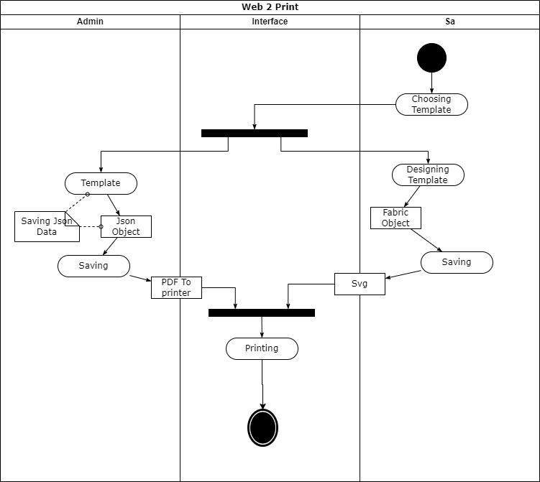

**Fig-3.1. User Case Diagram**

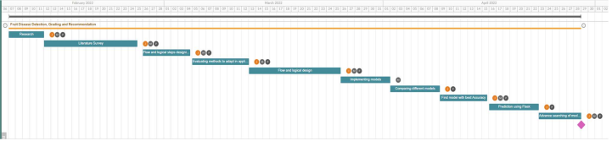

**Fig-3.2. Gantt Chart**

*­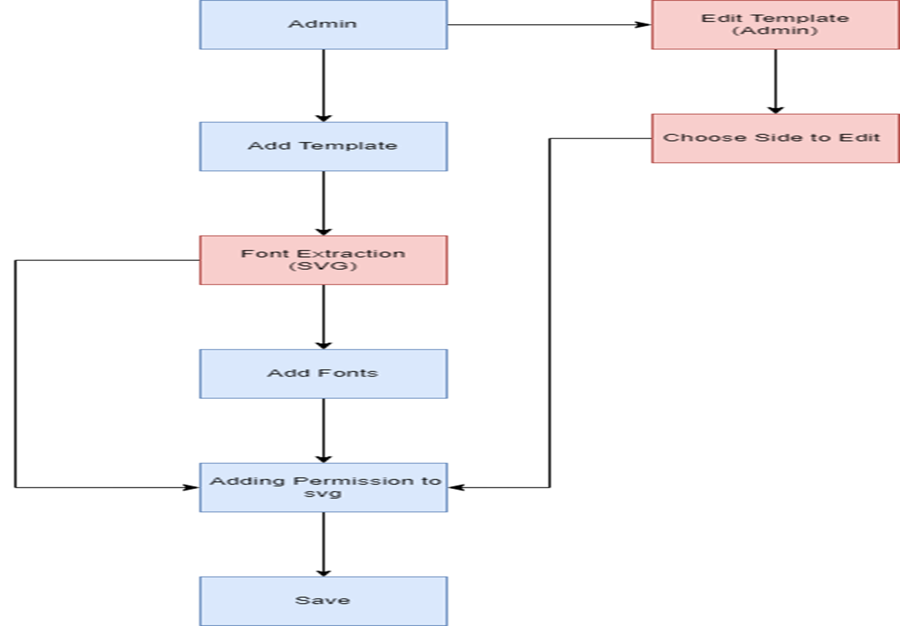*

**Fig-3.3 Flow Chart**

**3.1 Proposed Approach and Details**

We provide a front-end that corresponds to your procurement procedure for Print Orders.

Along with the customized GUI, you also receive a single, incredibly powerful online printing solution that has the following features and manages both your front end store front and specialized page for corporate clients:

a centralized administrative system to manage access, add new users, and establish accessibility guidelines. Use the WYSIWYG Java script editor to make quick changes to your designs, layouts, etc. A tool for publishing print-ready content pdf files. Complete back office process tool for managing print job administrative tasks. It takes hosting space to run the entire infrastructure, available print e-commerce website

Along with the customized GUI, you also receive a single, incredibly powerful online printing solution that has the following features and manages both your front end store front and specialized page for corporate clients -

a centralized administrative system to manage access, add new users, and establish accessibility guidelines. Use the WYSIWYG Java script editor to make quick changes to your designs, layouts, etc. A tool for publishing print-ready content pdf files. Complete back office process tool for managing print job administrative tasks. It takes hosting space to run the entire infrastructure. Available print e-commerce website

**3.2 Innovation in Idea**

Our system offers functionality that is not present in the current systems, allowing the user to customize the design to their liking. In addition, our approach significantly lowers production costs without sacrificing quality.

**3.3 Timeline**

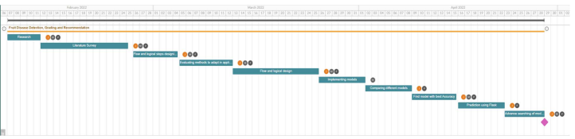

**Fig-3.4. Timeline of Project development**

**Chapter 4: Implementation Details and Results**

We have implemented our project in React, Fabricjs, Three js for frontend development. Codeigniter for backend

**4.1 Technology Stack**

Fabric js : Fabric.js is a Javascript HTML5 canvas library. It is a fully open-source project with many contributions over the years. The library was originally developed in 2010 by Juriy Zaytsev, who also led the project until 2016. Since 2016, the project is led by Andrea Bogazzi



**Fig-4.1. Fabricjs**

React: React (also known as React.js or ReactJS) is a free and open-source front-end JavaScript library for building user interfaces based on UI components. It is maintained by Meta (formerly Facebook) and a community of individual developers and companies. React can be used as a base in the development of single-page, mobile, or server-rendered applications with frameworks like Next.js. However, React is only concerned with state management and rendering that state to the DOM, so creating React applications usually requires the use of additional libraries for routing, as well as certain client-side functionality.



**Fig-4.2. React js**

ThreeJs: Three.js allows the creation of graphical processing unit (GPU)-accelerated 3D animations using the JavaScript language as part of a website without relying on proprietary browser plugins. This is possible due to the advent of WebGL, a low-level graphics API created specifically for the web.

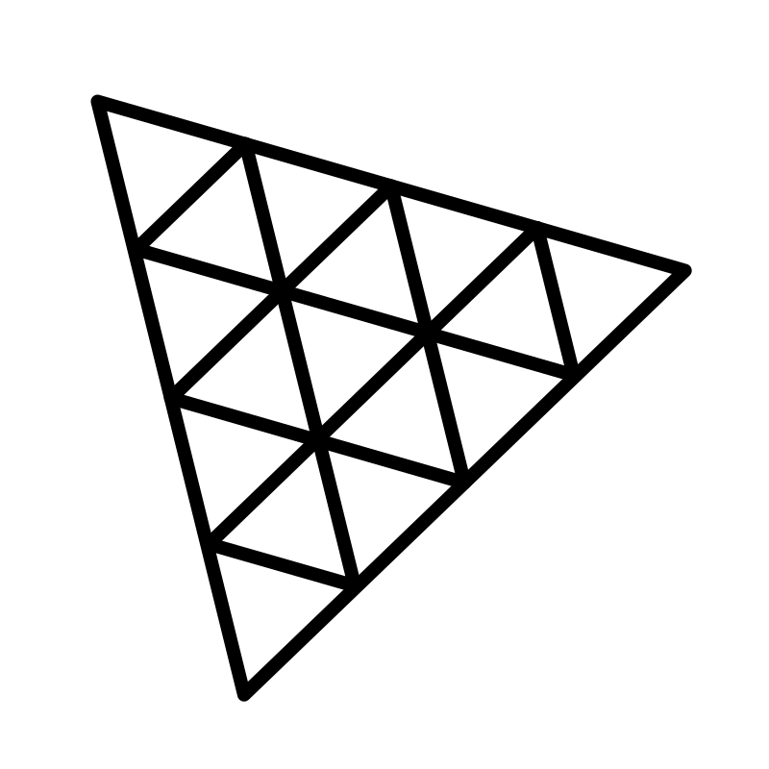

**Fig-4.3. Threejs**

Codeigniter: CodeIgniter is loosely based on the popular model–view–controller (MVC) development pattern. While controller classes are a necessary part of development under CodeIgniter, models and views are optional. CodeIgniter can be also modified to use Hierarchical Model View Controller (HMVC) which allows the developers to maintain modular grouping of Controller, Models and View arranged in a sub-directory format.



**Fig-4.4. Codeigniter**

**4.2 Preliminary Results**

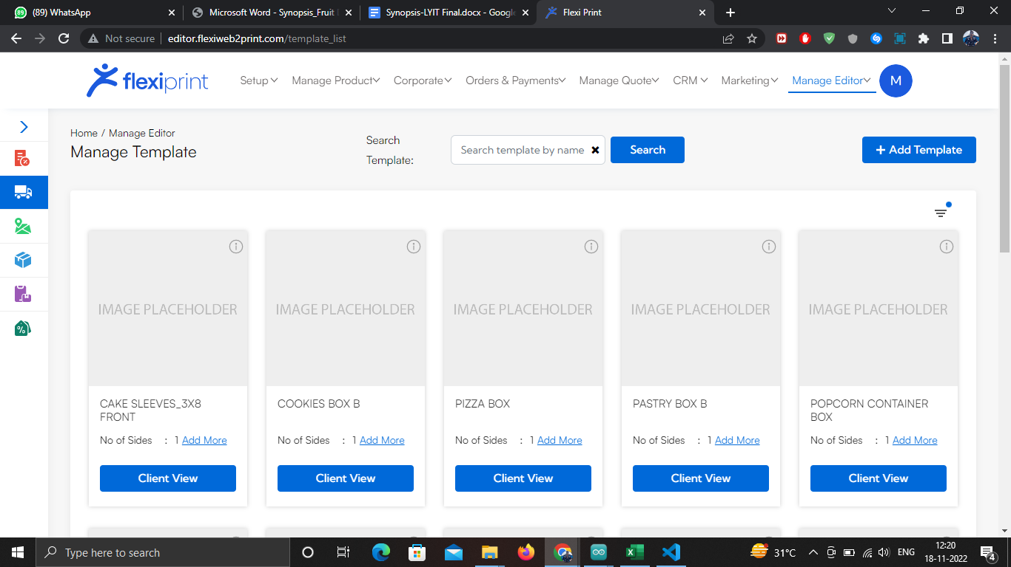

**Fig.4.5- All Listing Template (Admin side)**

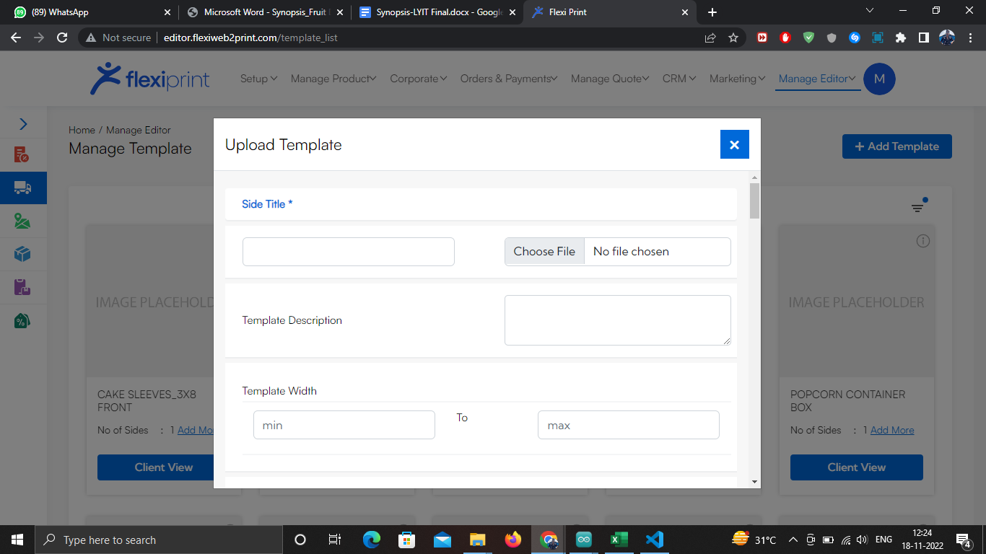

**Fig.4.6- Adding Template (Admin side)**

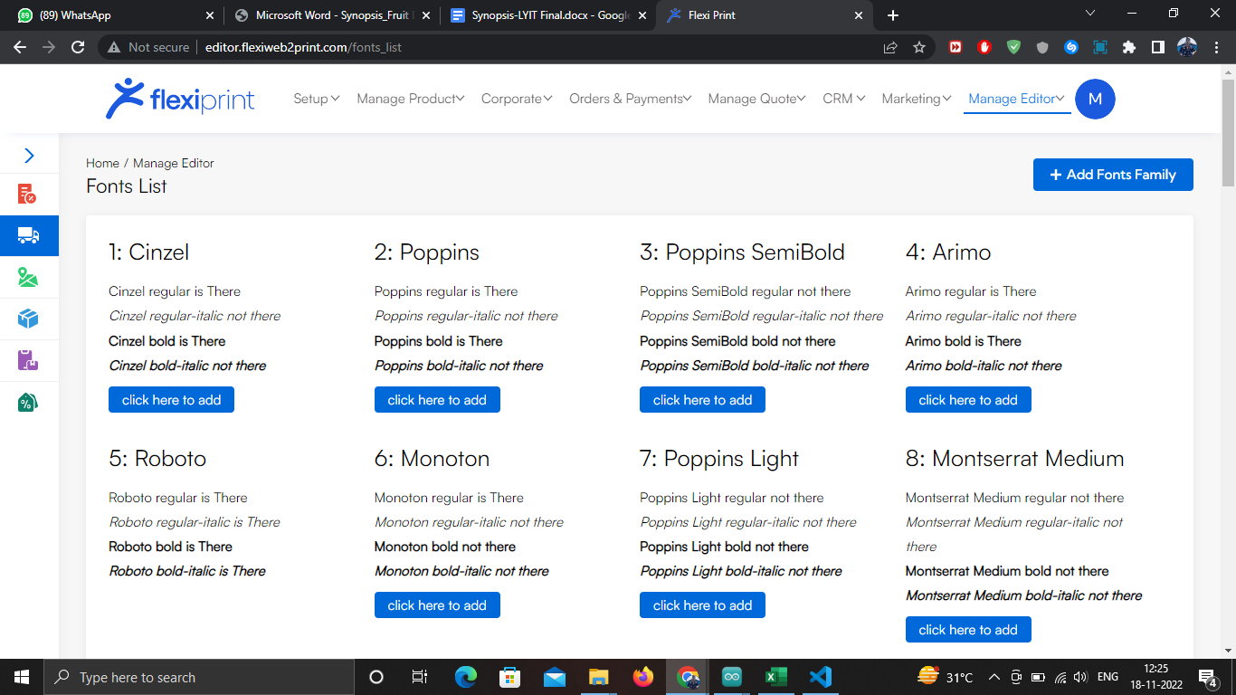

**Fig.4.7- Manage Fonts (Admin side)**

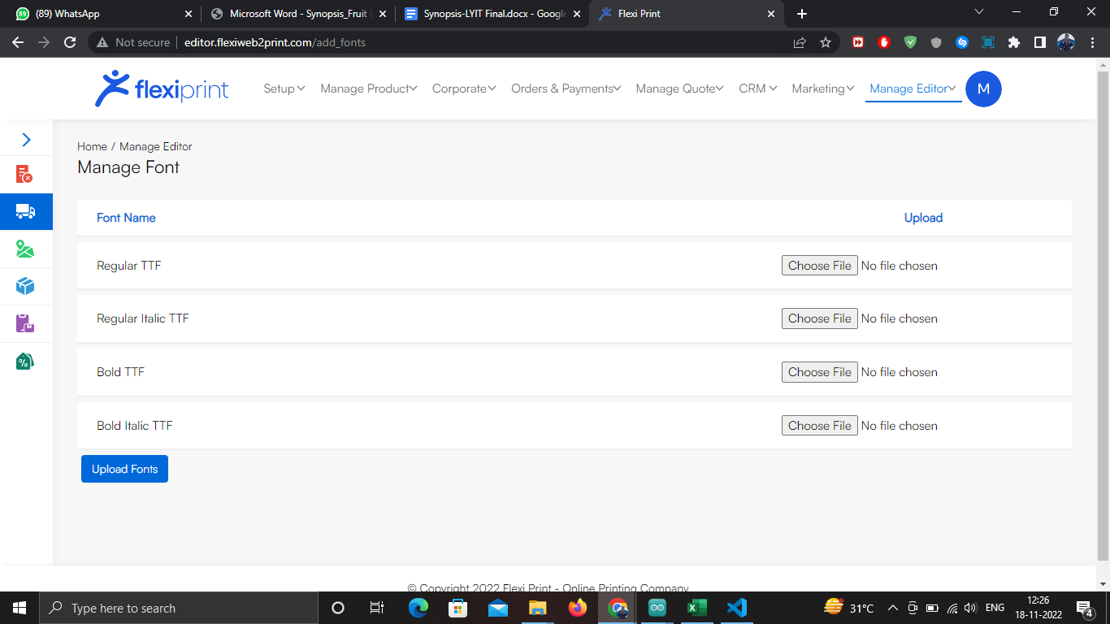

**Fig.4.8- Add Fonts (Admin side)**

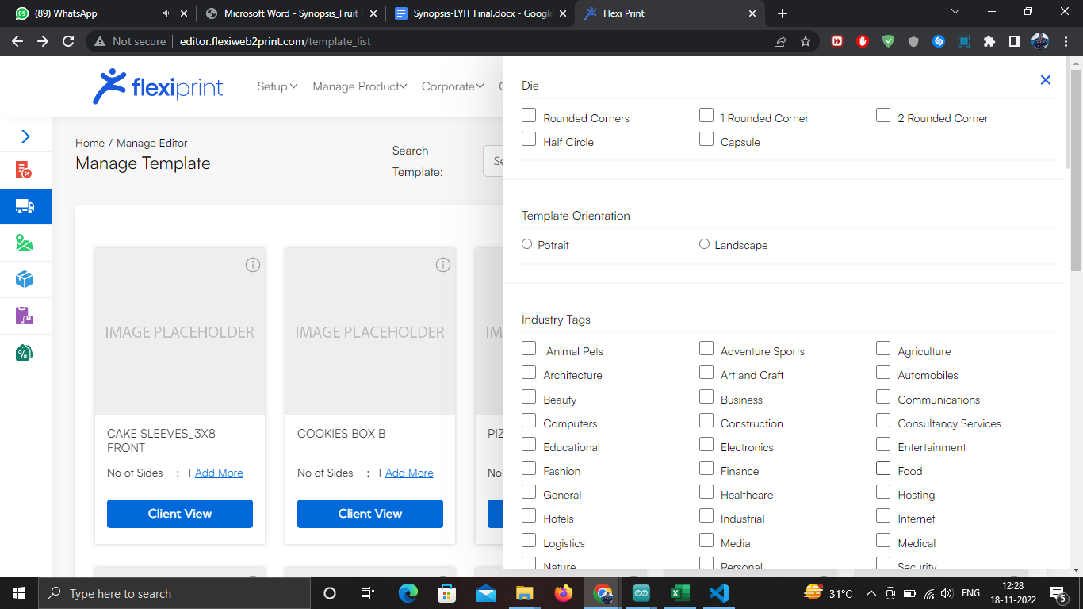**Fig.4.9- Filtering Template(Admin side)**

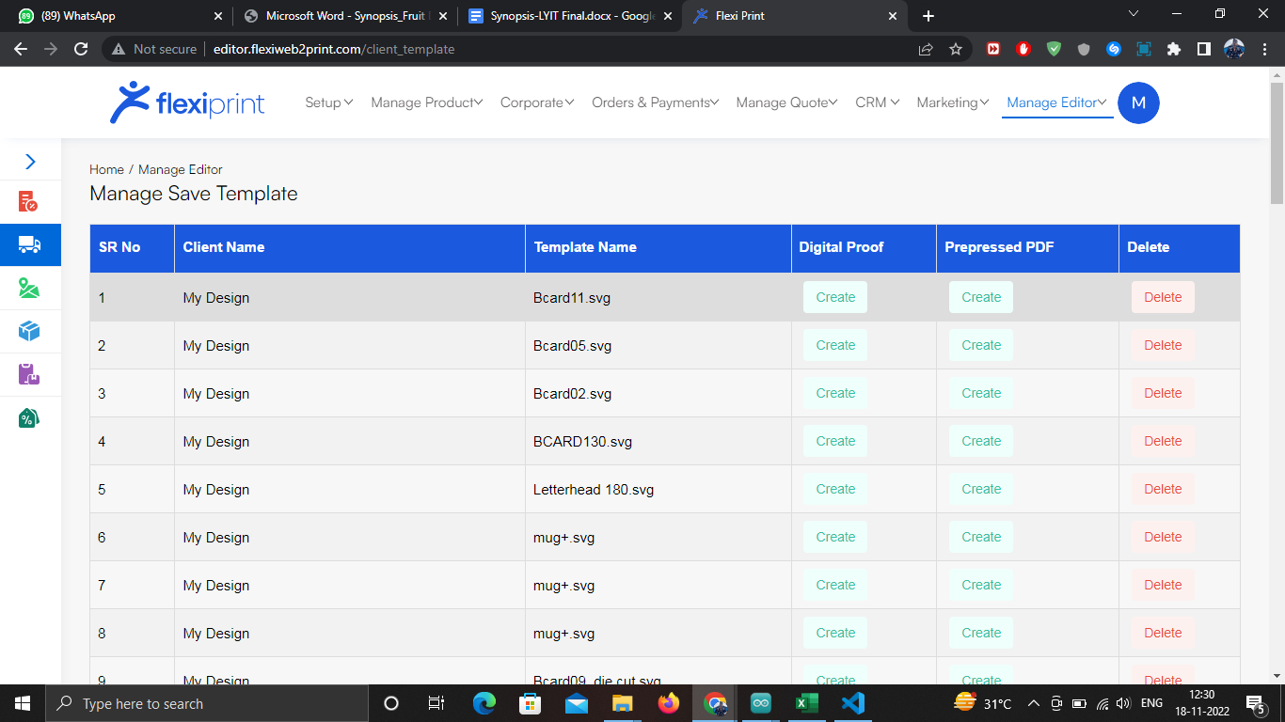

**Fig.4.10- Saved Order(Admin side)**

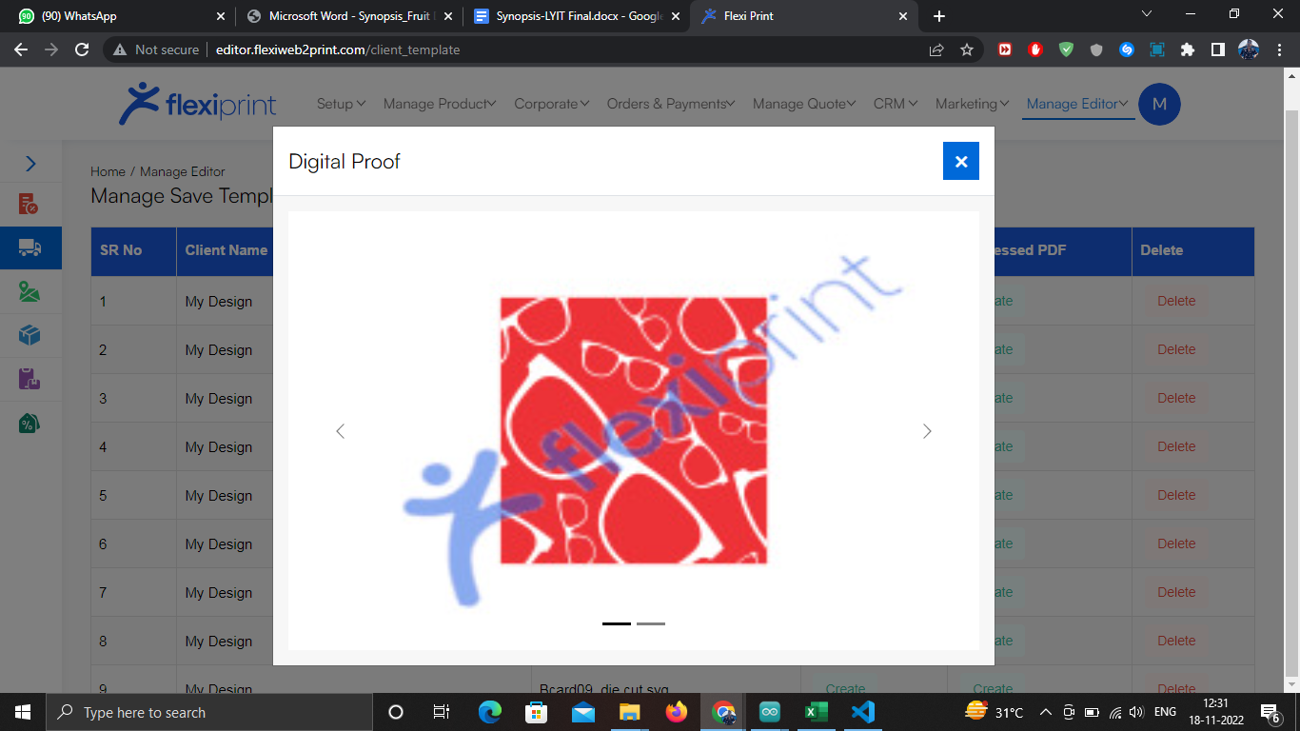

**Fig.4.11- Digital Proof(Admin side)**

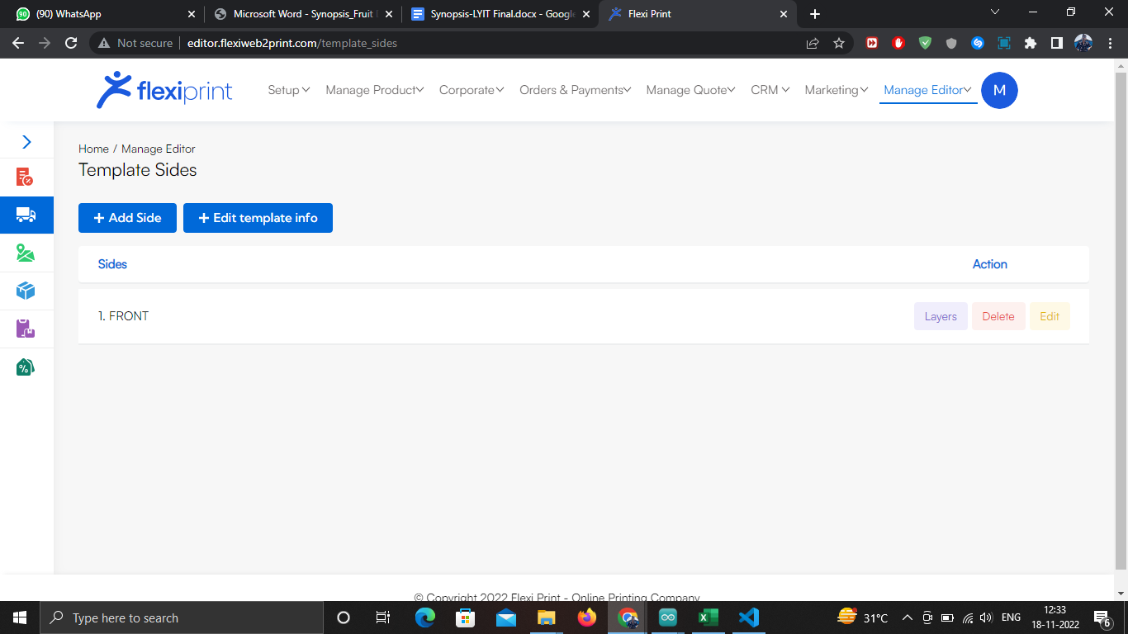

**Fig.4.12-Add More Side (Admin side)**

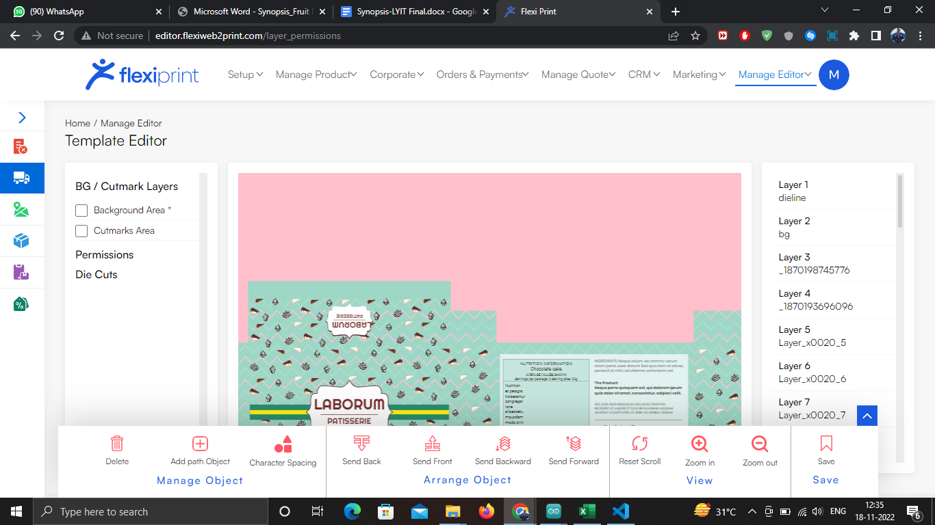

**Fig.4.13-Editing Side giving permission(Admin side)**

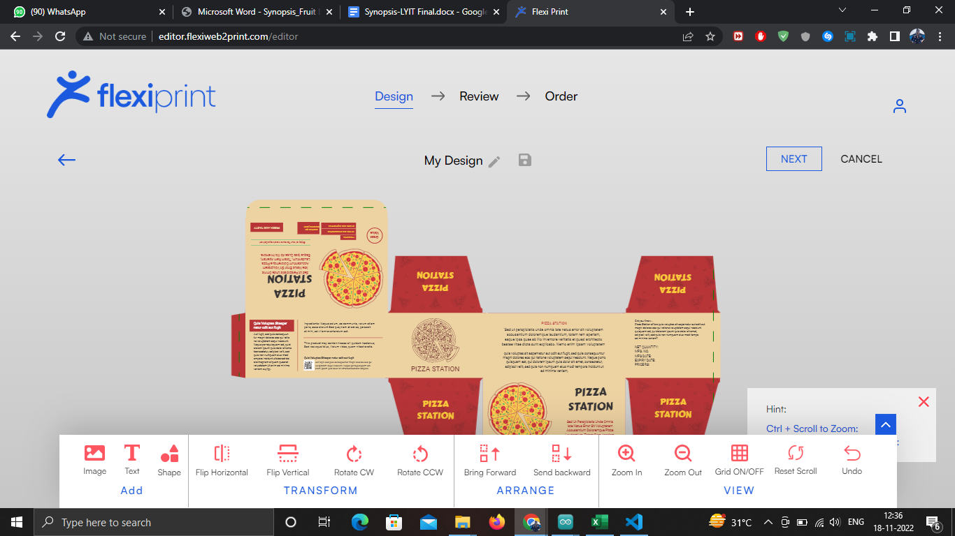

**Fig.4.14-Client Side Editing Side(Admin side)**

**Chapter 5: Conclusion and Result**

**Conclusion:**

The method of collaborative asynchronous data loading and on-demand rendering of 3D models can effectively shorten the initial loading time of the model. The improvement for model loading efficiency is particularly evident, especially in scenarios with complex interactions, in which the model carries multiple independent animations.

The optimization has different effectiveness in different computing and network environments. Specifically, when the computation capabilities and network bandwidth are gradually reduced, the optimization efficiency of rendering is more prominent

**Result:**

For this semester, we have completed the admin side. The admin will upload the customized template in svg format, add the desired custom fonts, grant access for the multiple layers of the templates for the editing convenience of the user.

**Chapter 6: References**

.

[1] A. Syberfeldt, O. Danielsson, and P. Gustavsson, “Augmented Reality Smart Glasses in the Smart Factory: Product Evaluation Guidelines and Review of Available Products,” IEEE Access, vol. 5, no. 99, pp. 9118– 9130, 2017.

[2] X. Qiao, P. Ren, S. Dustdar, and J. Chen, “A New Era for Web AR with Mobile Edge Computing,” IEEE Internet Computing, vol. 22, no. 4, pp. 46–55, 2018.

[3] M. Mina, C. Vijay, S. S. Tsai, C. David, and G. Bernd, “Interframe Coding of Feature Descriptors for Mobile Augmented Reality,” IEEE Transactions on Image Processing, vol. 23, no. 8, pp. 3352–67, 2014.

[4] T. Engelke, M. Becker, H. Wuest, J. Keil, and A. Kuijper, “MobileAR Browser–A generic architecture for rapid AR-multi-level development,” Expert Systems with Applications, vol. 40, no. 7, pp. 2704–2714, 2013.

[5] D. Chatzopoulos, C. Bermejo, Z. Huang, and P. Hui, “Mobile Augmented Reality Survey: From Where We Are to Where We Go,” Ieee Access, vol. 5, pp. 6917–6950, 2017.

[6] C. Marrin, “WebGL Specification,” Khronos WebGL Working Group, 2011.

[7] M. Baker and J. Manweiler, “Views of Current and Future Technology,” IEEE Pervasive Computing, vol. 16, no. 2, pp. 9–13, 2017.

[8] E. G. Larsson, O. Edfors, F. Tufvesson, and T. L. Marzetta, “Massive MIMO for Next Generation Wireless Systems,” IEEE Communications Magazine, vol. 52, no. 2, pp. 186–195, 2014.

[9] H. Hoppe, “Progressive Meshes,” Proceedings of the 23rd annual conference on Computer graphics and interactive techniques, pp. 99–108, 1996.

[10] R. Pajarola and J. Rossignac, “Compressed Progressive Meshes,” IEEE Transactions on Visualization & Computer Graphics, vol. 6, no. 1, pp. 79– 93, 2002.

[11] A. Maglo, I. Grimstead, and C. Hudelot, “POMAR: Compression of progressive oriented meshes accessible randomly,” Computers &

[12] J. H. Clark, Designing surfaces in 3-D, Commun. ACM, vol. 19, no. 8, pp. 454–460,Aug.1976

[13] J. J. LaViola and D. F. Keefe, 3D spatial interaction: applications for art, design, and science, in ACM SIGGRAPH 2011 Courses, New York, NY, USA, 2011, pp. 1:1–1:75.

[14] T. M. Takala, R. Pugliese, P. Rauhamaa, and T. Takala, Reality-based User Interface System (RUIS), in 3D User Interfaces (3DUI), 2011 IEEE Symposium on, 2011, pp. 141–142.

[15] Laméris Ootech, TNO Test for Stereoscopic Vision. Netherlands Organization for Applied Scientific Research, 1972